Version |  | V3.0
Status |  | Final Version
Filename |  | MFG180 - CMM User Manual Explicit Participant – V3.0.DOCX
Date |  | 31/08/2019
Author |  | XBID Project Team
Reviewer |  | XBID Project Manager
MFG180 - CMM User Manual Explicit Participant
XBID

Chairman of the
Supervisory Board
Dr. Joachim Faber

Executive Board
Carsten Kengeter (CEO)
Andreas Preuß (Deputy CEO)
Gregor Pottmeyer
Hauke Stars
Jeffrey Tessler

German stock corporation registered in
Frankfurt/Main
HRB No. 32232
Local court: Frankfurt/Main

Deutsche Börse AG

Mailing Address
Mergenthalerallee 61
65760 Eschborn
Web
www.deutsche-boerse.com

Table of Contents
1. General 4
1.1 Purpose 4
1.2 Intended Audience 4
1.3 Referenced Documents 4
2. Introduction to CMM 6
2.1 CMM functionality for Explicit Participants 6
2.2 CMM Delivery Intervals and Contracts 6
2.3 ATC calculation 7
2.3.1 Detailed ATC Calculation 8
2.4 Allocation Timeline 9
2.4.1 Capacity Allocation Timeline 10
3. Access 12
3.1 System Requirements/Prerequisites 12
3.2 System Access 12
3.2.1 Initial authorization 12
3.2.2 Login 12
3.2.3 Session timeout 15
3.2.4 Single Session Login 15
3.2.5 Connection failures 15
4. Common window elements 17
4.1 Used window elements 17
4.1.1 Range filter 17
4.1.2 Drop-down list 17
4.1.3 Date picker 17
4.2 Export and Import functionality 18
4.3 Messages log 18
4.4 Reports download 18
5. Capacity Overview Window 20
5.1 Capacity Overview Section 20
5.1.1 Description 20
5.1.2 Functionality 20
5.1.3 Screen elements 25
5.2 Main 25
5.2.1 Logout 25
5.3 Preferences 26
5.3.1 Show Contract UTC / Contract Local / Contract CET Time 26
5.3.2 Select Local Time Zone 27
5.3.3 Filter Contracts 29
5.4 Interconnector 31
5.4.1 Change Border 31
5.5 Reports 33
5.5.1 Description 33
5.5.2 Functionality 33
5.5.3 Screen elements 33
5.6 Help 35
5.6.1 Description 35
5.6.2 Functionality 35
5.6.3 Screen elements 36
5.7 Reload 36
5.7.1 Description 36
5.7.2 Functionality 37
5.7.3 Screen elements 37
5.8 Messages Section 37
5.8.1 Description 37
5.8.2 Screen elements 37
6. Explicit Participant Files 38
6.1 BG Request file 38
6.1.1 BG Request XML-Schema 38
6.2 BID File 42
6.2.1 BID XML-Schema 43
6.3 BG Allocation file 46
6.3.1 BG Allocation XML-Schema 46
6.4 Result Document (RED) 50
6.4.1 RED XML-Schema 50
6.5 Right Document (RID) 54
6.5.1 RID XML-Schema 55

General
This document provides a detailed description of the XBID – CMM GUI for explicit participant users.

The description of the GUI is subdivided in several sub-chapters, which are all organised in the following way:

- Description: This section gives a brief overview of the information included in the sub-chapter.
- Functionality: This section describes the functionality of the sub-chapter.
- Screen Elements: In this section the related screen elements are shown and described.

Note: Data contained in the screenshots and samples in this publication are for illustrative purposes only and should not be relied upon as a true representation. Cross references to other chapters within this document are always clickable, but not marked separately. Changes applied to this document after the last version has been published (other than grammar/ spelling corrections) are marked with a change bar in the left margin as demonstrated in this paragraph. Old change bars are removed from version to version.

Purpose
This document is intended for Explicit Participants personnel using the system. The purpose of the “CMM - User Manual” is to identify the supported business functions, explain the structure and the content of the windows, and familiarize the user with the “look and feel” of the CMM - GUIs and its features. This user guide is intended to be a reference guide, where information about GUI windows can be quickly retrieved. It focuses on giving detailed descriptions of all windows and related functions.
The user guide consists of 5 chapters and an appendix:
- Chapter 1 “General” introduces the user guide and gives an overview about fundamentals of the user guide.
- Chapter 2 “Access” gives an overview on different “Access” related topics.
- Chapter 3 “Common window elements” describes generic functions of the application.
- Chapter 4 “Capacity Overview Window” describes the Capacity Overview GUI in detail.
- Chapter 5 “Explicit Participant Files” describes XML files which can be configured for information exchange between CMM and Explicit participant.

Intended Audience
This document is intended for the following user groups:
- Internal Testers
- Explicit Participants

Referenced Documents
This document refers to:
- PPI160 Key Terms and Glossary
- HLS100A Functional Description Capacity Management Module (CX3227)
- DFS800 Capacity Management TSO Interface

Introduction to CMM
The XBID system is a 24/7 energy trading and capacity management solution designed to enable cross border intraday trading.
Its prime components are the Shared Order Book (SOB), the Capacity Management Module (CMM) and the Shipping Module (SM).
- No specific software installation necessary
- 24/7 access to the service
- Continuous explicit and implicit allocation of network capacity
- Direct connection to the XBID Trading Module for implicit allocation of network capacity
- Public Message Interface for explicit allocation

CMM functionality for Explicit Participants
- Processing of Capacity Requests
- Reporting on request via the Participant GUI
- A programming messaging interface (PMI) enabling participants to connect their in-house applications directly to CMM for capacity allocation, as well as the Trading Module for implicit capacity allocations via power exchange

CMM Delivery Intervals and Contracts
Delivery interval in CMM is a defined time interval representing the smallest unit which can be allocated on by an explicit participant or by TSO with the on-behalf allocation function.
- Example: 13:00-14:00, Q13:00-13:15
- It is defined on the interconnector level
- In the CMM it is often referred as “Contract”, which is not entirely correct
- Allocated directly on ICs as explicit allocations
Contract in SOB is a tradable instrument.
- It is generated based on the parameters of in-SOB defined products and then made available for trading in delivery areas
- Trades made with contracts are then allocated in CMM to individual interconnectors as implicit allocations
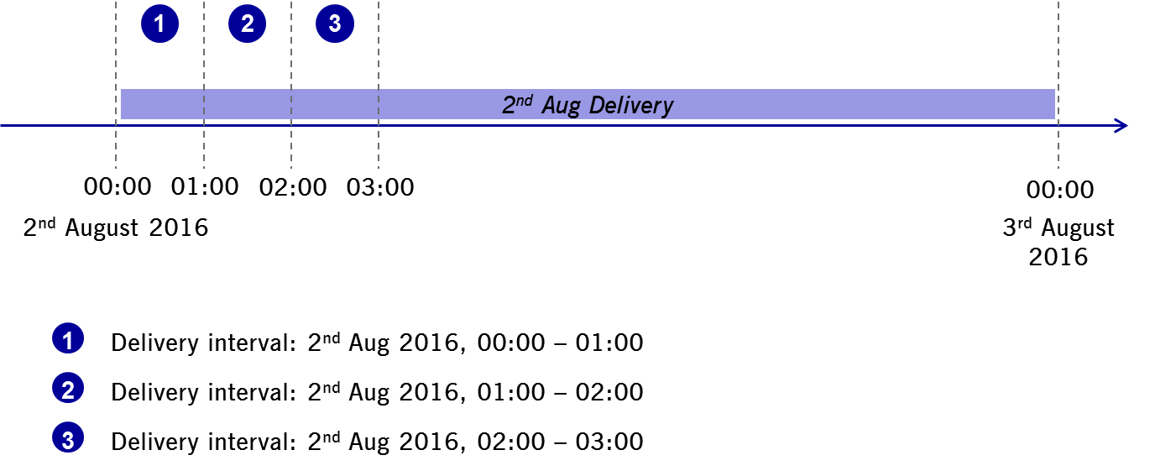
Delivery Intervals
Delivery intervals and Contracts relation:
- Only contracts with length equal or equal to the multiply of the delivery interval length may be allocated on the that interconnector
Delivery Interval | Contract | May be traded on the IC
15min | 15min | Yes
15min | 60min | Yes
60min | 15min | No
60min | 60min | Yes
30min | 15min | No
30min | 60min | Yes

ATC calculation
ATC – Available Transfer Capacity shows the actual capacity available for allocation in that direction and delivery interval. It is calculated as (more detailed calculation on the next slide):
ATC = NTC – ExpA - ImpA
NTC - Network Transfer Capacity shows the total capacity as provided by the interconnector managing TSO(s)
Explicit Allocations (ExpA) – Allocations made by explicit participants
Implicit Allocations (ImpA) – Implicit allocations made via implicit allocation requests

Detailed ATC Calculation
Detailed ATC per direction is as follows:
ATC _{A->B} = NTC _{A->B} - AAC _{A->B} + AAC _{B->A} - Intraday Allocations _{A->B} +
+ Intraday Allocations _{B->A} - BM/GenOutage _{A->B} + GenOutage _{B->A}
AAC – Already Allocated Capacity is capacity reserved even before the start of capacity allocation (= CAS and CBS)
Intraday Allocations - ExpA + ImpA
BM/GenOutage - Balancing or GenOutage Allocations made in the special allocation phase (after the regular allocation phase), it depends on the IC configuration.
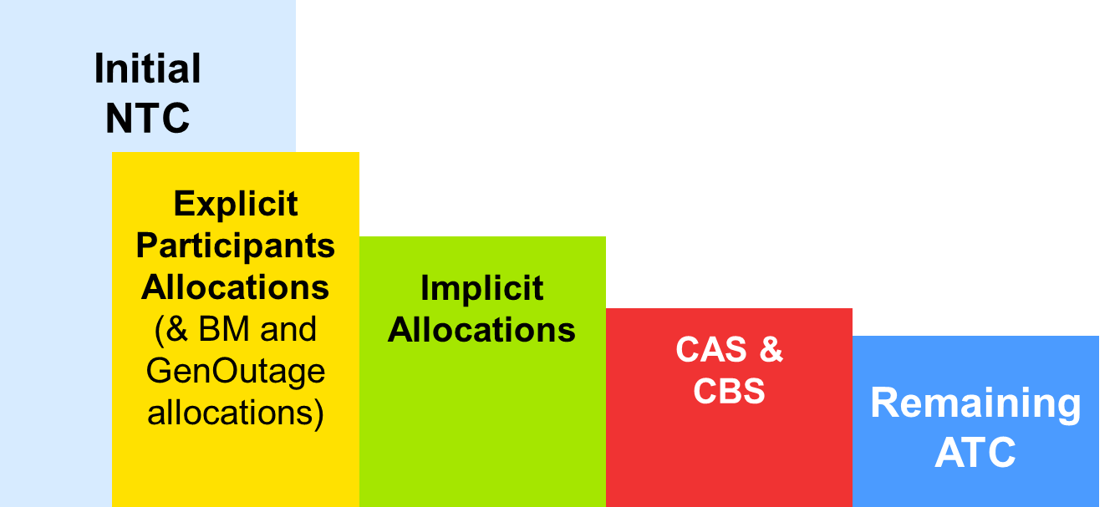
Capacity Distribution
NTC – Explicit Allocations – Implicit Allocations – CAS & CBS = ATC
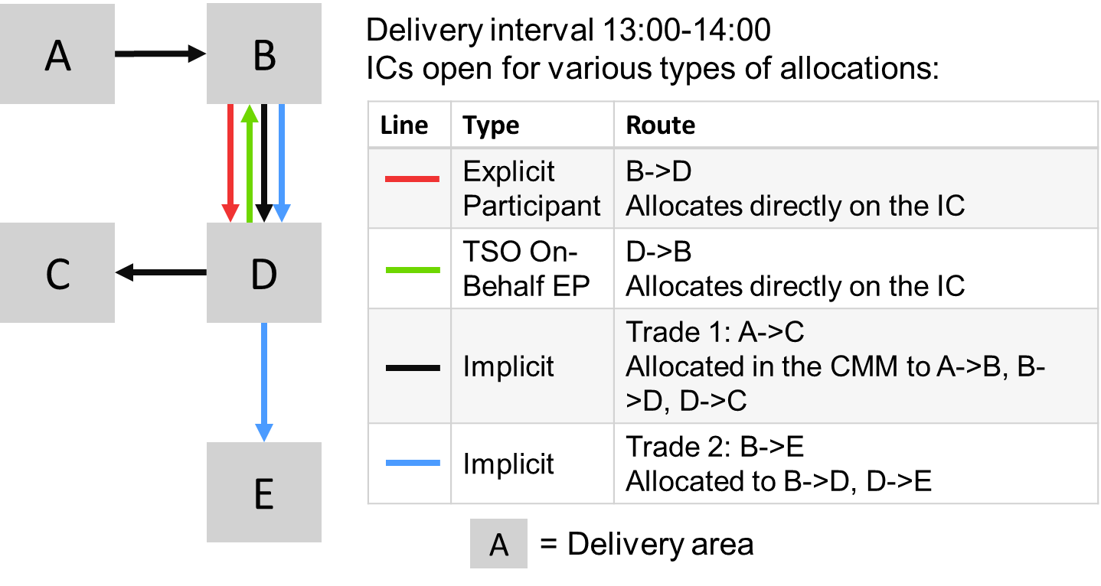
Capacity Distribution Example

Allocation Timeline
The CMM works in concept of the allocation gate opening and closing. This means, that in this period capacity allocation can be made.
The capacity allocation process consists of the following steps in the presented order:
- Upload of capacity information
- Calculation and publishing of available capacity
- Gate opening and allowing capacity allocations
  - Implicitly, via intraday power trading users
  - Explicitly, via Explicit Participants
  - Communication of allocated capacity
- Gate closure and communication of allocated capacity
These parameters are configured on the interconnector level:
Opens At – Gate opening, i.e. when the allocation is possible for the DIs of the next day.
Closes Before – When the allocation gate closes for a DI before its delivery starts.
Balancing Ends Before, Gen Outage Ends Before – When gate for special allocations closes before the delivery of the DI commences.
- Capacity is allocated on a first come - first serve basis - there is no allocation based on price
- Each capacity request receives a unique ID upon receipt by the application server
- After an allocation the ATC is updated and displayed to all users
  - At the same time the available capacity is sent to the SOB Module and the H2H matrix is updated - in this way the allocation process may continue until gate closure

Capacity Allocation Timeline
The capacity allocation lifecycle consists of the following steps in the presented order:
- Upload of capacity information
- Calculation and publication of available capacity
- Allocation of capacity from the gate open (3) time
- Implicit (Trading)
- Explicit (Explicit Participants, TSOs on behalf of EPs)
- Gate closure and communication of allocated capacity
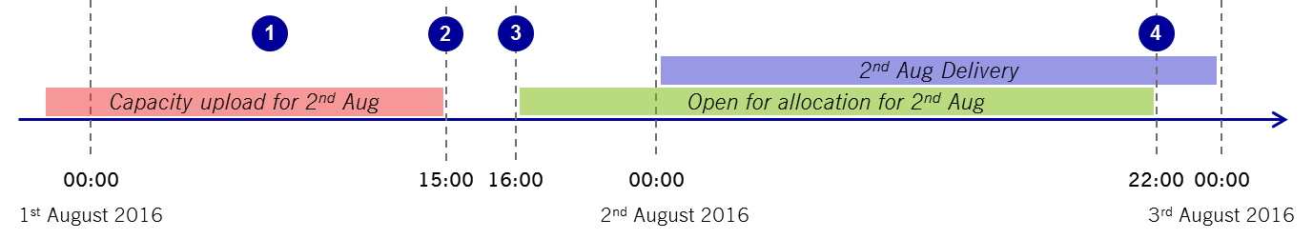
Capacity Allocation Timeline
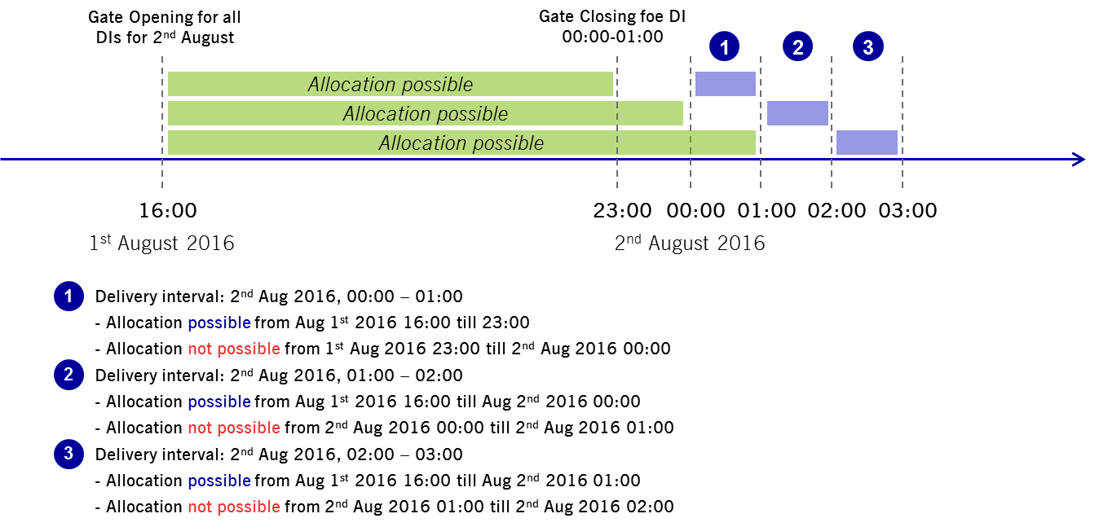
Delivery Intervals and Allocation

Access

System Requirements/Prerequisites
The CMM - GUIs are web based applications which are accessed via a web browser. No application software needs to be installed locally on the user’s PC. In order to run the respective GUIs the following technical requirements and prerequisites have to be fulfilled.
Technical requirements:
- The latest or one older version the following supported web browsers must be installed:
  - Microsoft Internet Explorer
- SSL transport and JavaScript must be enabled
Prerequisites:
- A certificate (generated by DBAG Certificate Authority) needs to be installed in the browser.
- A login identification and password for the respective CMM-GUIs with respective user privileges need to be available.

System Access

Initial authorization
In order to gain access to the Capacity Management Module GUIs the Explicit Participant must be authorized by XBID-CMM. Therefore, the following steps have to be taken:
- In the first step, the Explicit Participant must provide the user ID and contact details of a security administrator to Services & Admission. This person is granted CMM access.
- The security administrator then receives a randomly created password via email.
- With this initial password the user can log in to the Capacity Management Module GUIs. On the first successful login a password change is required.

Login

Description
The Login window is the first view that is presented when accessing the Capacity Management Module GUIs. It is used to log in to the application and to change the user password.

Functionality
Login
To login to the Capacity Management Module GUIs open web browser and open URL provided by DBAG. Enter the user credentials into the Username and Password fields and click the Login button.
Change Password
In general, the password to login to the application has no expiration.
A password change is mandatory if an initial or reset password is used for login. In addition to these cases, a password can be changed manually at any time via the Change Password tab. The user name and the current password have to be entered to authenticate the user. Then, the new password must be entered twice to prevent typos in the spelling. The password change is effective immediately.
It is recommended that the new password complies with the following rules:
- At least 8 characters long
- Use at least one character from each of the following categories: numeric characters (0-9), uppercase letters (A-Z), lowercase letters (a-z)
- Differ from the last 10 passwords

Screen elements
Login
Login screen

Login – Fields
Field | Description
User Name | User ID of the user who is supposed to be logged in.
Password | Password that belongs to the entered user ID.
Change Password
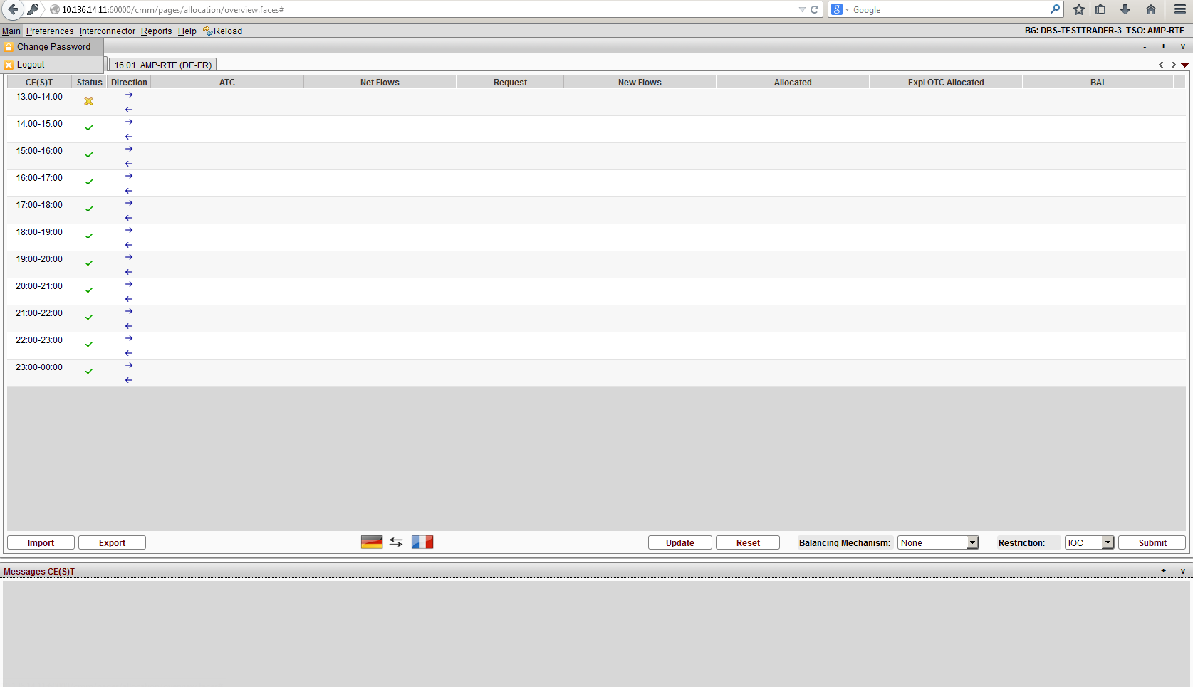 Step 1. Press Change Password button
Access of Change Password screen
Step 2. Enter new password
Change Password screen
Change Password – Fields
Field | Description
Old Password | Current password that belongs to the entered user ID.
New Password | The new password has to comply with the complexity requirements.
Repeat New One | To prevent typos in the password, the new password must be entered a second time.

Session timeout
The Capacity Management Module GUIs have a session timeout defined on the server level, it is common for all users.

Single Session Login
The single session login functionality restricts each authorized CMM user to login to the service one time per Login ID. If a user is already logged into CMM with a Login ID, a second login attempt with the same ID will only be successful once the first login session has been terminated.
In such a situation the following dialogue window is displayed. If the second user decides to continue, the first user is logged out.
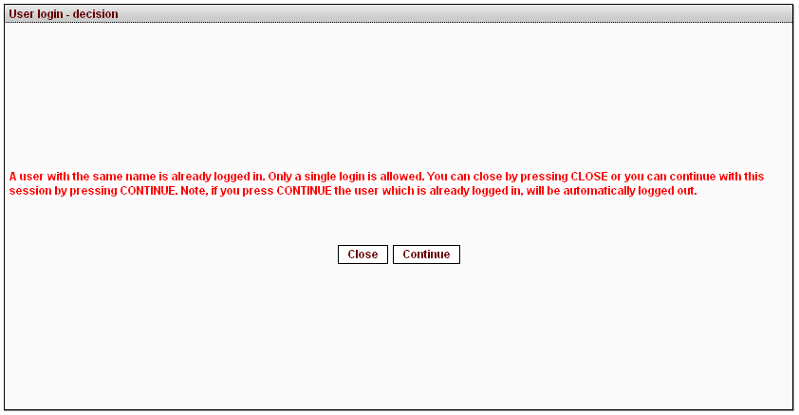
Single login dialogue window

Connection failures
The Capacity Management Module GUI is a web based application in which all functions are triggered by user requests. Hence, no automatic notifications inform the user in case of a connection failure. Depending on the reason for a failure, different kinds of behaviour may occur:
Backend failure | In case the connection to the backend at DBAG is interrupted, every attempt to send a request to the backend results in an error message displayed in the message bar of the current window. Only data which has been received prior to the interruption can be viewed in the GUI.
Missing encryption certificate | If a user attempts to access the Capacity Management Module GUI without a valid certificate, a browser error is shown. And the default error page of the given browser is shown..
Web server failure | If the web server which hosts the Capacity Management Module GUI happens to be unavailable, the browser will display an error page informing the user that the web server is unable to show the requested page. In this case, no interaction with the GUI is possible.
Network failure | Since the Capacity Management Module GUI is a web based application, no interaction is possible if the network connection is faulty. Should the connection via leased line be interrupted, the user can use the URL for Internet access to the Capacity Management Module GUI with the same certificate as used for leased line access. In case the Internet connection is interrupted, DBAG is not responsible for the failover concept. With the exception of network failures all connection failures have the same effect as a logout, i.e. the user session is terminated. To access the GUI after the problem has been solved, the user needs to login again.

Common window elements
The following section provides an overview of the standard window components and introduces specific terms that are used in this document. The look and feel of the CMM GUIs may differ slightly depending on the used operating system and web browser.

Used window elements
Each window is built from graphical window elements used to show information in CMM GUI or change behaviour of this GUI.

Range filter
Range filter is used for limiting range of displayed records, i.e. delivery intervals in Capacity Overview window.
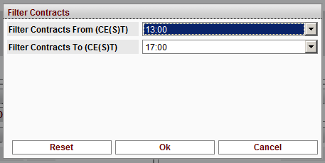

Drop-down list
Drop-down lists are used for showing the possible values, which can be assigned to a respective parameter. In the screenshot below the user can select a direction on a border.
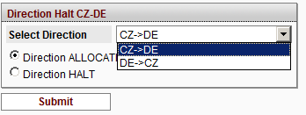

Date picker
The Date picker is used to select a correct date. The user clicks on the red-white icon and the date picker window will show up allowing user to choose a correct date. Should the user need to change a month, click on left or right arrows shown next to the current name of the month and year.
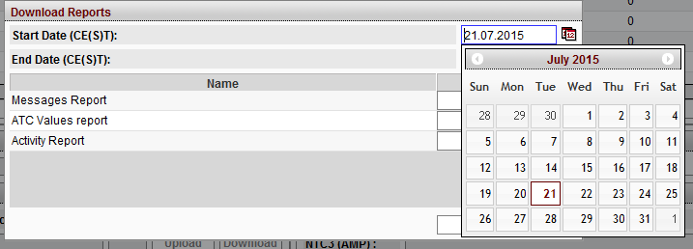

Export and Import functionality
Export functionality in general serves for exporting BG Allocation (BGA), Result Document (RED) or Rights Document (RID) files.
With the ‘Import’ button a user can upload a BID or a BG allocation file based on the ENTSO-E ECAN standard. The file contains capacity requests for the balancing group.
Exported data are either in the form of a CSV file (BG Allocation CSV) or an XML file (BG Allocation XML, Result Document or Rights Document.

Messages log
The messages log shows user submitted or system generated messages. Each message contains time stamp when the message was created, icon showing priority of the message and the message text itself.
The Messages log section example:
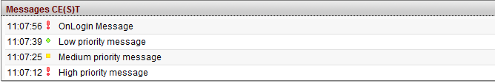

Reports download
Reports download is common functionality among multiple roles which user can have within CMM. It is started by clicking “Reports” in menu. The window contains date pickers for start and end dates and a table with a list of available report types, each accompanied by “Download” button.
User first sets start and end date and then clicks the “Download” button for each requested report. After download of all requested report, user clicks the “Close” button and the “Download Reports” dialog window disappears.
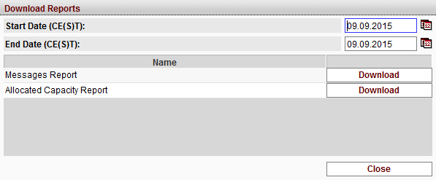

Capacity Overview Window
The Capacity Overview window can be accessed by login in as Explicit Participant User. It is divided in two sections, which are described in the following:
- Capacity Overview Section:
The Capacity overview section offers the Explicit Participant User information about the daily capacity values for today and the next day.
- Messages Section:
In the Messages section the last 25 messages are displayed. It displays the following kind of messages:
- System messages (e.g. login/logout information, allocations, halt etc.),
- Error or warning messages (e.g. Service Halt, etc.).

Older messages can be seen in the Message Report (See 3.4 Reports download for further details).

Capacity Overview Section
As described above, the Capacity Overview section offers the Explicit Participant User information about the daily capacity values for today and the next day. It consists of 2 tabs:
- Daily Capacity information for today with the naming convention ‘DD.MM. (CE(S)T) Border’
- Daily Capacity information for tomorrow with the naming convention ‘DD.MM.(CE(S)T) Border’

Description
There are two tabs for the daily capacity in the Capacity Overview window, one for the current day (today) and one for the next day (tomorrow). When the calendar day changes the tabs switch to the respective new dates (current and next). This is a time-driven event.
Note: The calendar day here is the calendar day of the platform i.e. CE(S)T.

Functionality
Daily Capacity Overview
The following information is displayed in the tabs for the selected border for today and tomorrow and for the respective delivery interval. The values are updated at a, platform wide, configurable interval e.g. 10 seconds or when the ‘Reload’ button is pressed:
- Time
There are three possible Time columns, CE(ST) Time, Local Time and UTC Time. The columns which are displayed are determined by the users preferences selection with the CE(S)T Time column being mandatory and the other two being optional. Each column displays all delivery intervals, which have not been delivered yet or which are in delivery, for the selected date. Contracts for the following day are preceded by the letter ‘T’ and the date is determined by the system time, i.e. CE(S)T.

- Status Symbol (status of delivery interval)

- Direction Symbol
Column 3 indicates which direction the subsequent columns are referring to for the selected interconnector or border.

- ATC
This column displays the available transmission capacity per delivery interval and direction. Values are in MW. Decimal places can be shown. Number of decimal places is configured for each border separately.
- Net Flows
This column contains the total capacity which has already been allocated for all balancing groups from the CAS/CBS files plus all intraday allocations made within CMM by the selected Balancing Group. Values are in MW. Decimal places can be shown. Number of decimal places is configured for each border separately.

- Request
In column 6, Request, additional capacity can be requested for each active delivery interval and direction by manually entering values into the entry fields. Values are in MW. Decimal places can be entered. Number of decimal places and maximum quantity per request are configured for each border separately.

- New Flows
Column 7 displays the projected new netted flow for the selected balancing group (sum of the columns Net Flows and Request). The column is updated when a user manually enters a value into column 4, Request, and clicks ‘Update’.
After the button ‘Submit’ is clicked this column contains the same value as the Allocated column (if the capacity is allocated).
Values are in MW. Decimal places can be shown. Number of decimal places is configured for each border separately.
- Allocated
Column 8 displays the total intraday capacity (TIC) which has been allocated for the respective delivery interval and direction. It includes all allocations from explicit as well as implicit requests. Values are in MW. Decimal places can be shown. Number of decimal places is configured for each border separately.
- Explicit OTC Allocated
Column 9 displayed the total capacity which has been allocated for the selected balancing group due to an over-the-counter request for the respective delivery interval and direction. Values are in MW. Decimal places can be shown. Number of decimal places is configured for each border separately.

- BAL (Balancing Allocations)
Column 10 displays the total intraday capacity which has been allocated due to explicit requests using a balancing mechanism or GenOutage request for the respective delivery interval and direction. This column is only displayed if a balancing mechanism or GenOutage is configured for the given border or interconnector. Values are in MW. Decimal places can be shown. Number of decimal places is configured for each border separately.

Note: In the following the Balancing Mechanism and GenOutage is described.

Balancing Mechanism
If this functionality is configured for the border, users which belong to the authorized balancing groups can define a request as a Balancing Mechanism request. This mechanism allows users to request capacity closer to delivery interval delivery than usual.
In order to submit a Balancing Mechanism request, the user has to select one of the Balancing Mechanism entity codes.
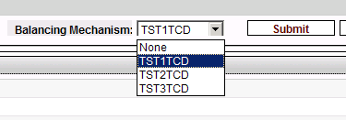
Balancing Mechanism entity code selection in Trading GUI
After selecting one of the entity codes from the drop down list the user has to click on ‘Submit’ when requesting capacity with Balancing Mechanism. This will open a confirmation popup window which has to be confirmed with ‘Yes’ or ‘No’.
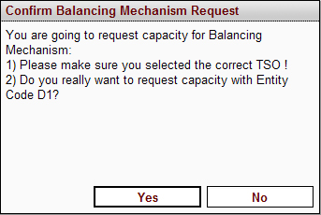
Figure 1: Confirmation window for Balancing Mechanism request
After a Balancing Mechanism request has been submitted, the entity code for capacity requests is reset to the default setting ‘None’ in the Balancing Mechanism dropdown box.
Once a Balancing Mechanism allocation has been submitted, a message appears in the trader’s messages panel confirming the details of the allocation.
Note:
- Allocations for Balancing Mechanism are not netted. This means that the capacity requested in a Balancing Mechanism allocation in direction B->A is deducted from direction B->A, but not added to the opposite direction A->B.
- Capacity can only be requested using the Balancing Mechanism for delivery intervals until a configurable time prior to delivery; this offset is normally smaller than the offset between delivery start and the standard gate closure time thereby creating a Balancing Mechanism phase during which only Balancing Mechanism or GenOutage (see below) requests can be accepted.

Note:
Balancing Mechanism (BM) is by default enabled for Internal Interconnector (MA-Internal), however it is not possible to allocate any capacity using BM as it is not assigned to any Border.
GenOutage
The GenOutage functionality allows predefined balancing groups to request capacity up to a predefined time prior to delivery (time can be configured). This differs from the BM-requests in that no special entity codes must be selected and the allocations are netted.

The columns in the Capacity Overview display the following information:
1 | 2 |  | 3 | 4 | 5 | 6 | 7 | 8 | 9 | 10
Time (Contracts) |  | Status Symbol | Direction Symbol A->B | ATC | Net Flows | Request | New Flows | Allocated | Expl OTC Allocated | BAL
 |  |  | Direction Symbol B->A | ATC | Net Flows | Request | New Flows | Allocated | Expl OTC Allocated | BAL

Capacity Overview Buttons
Five buttons are available to the Explicit Participant user under the daily capacity overview.
- Update:
The ‘Update’ button simulates the submission of new values and shows the forecast of the available transmission capacity in the column 5: New Capacity in red.
- Reset:
This button clears all entries in the input fields.
- Submit: This button submits Allocation requests to CMM. The different kinds of Allocation methodologies (ACE, IOC and AON) are described in Chapter 2.15 in the HLS100a document.
- Import
The ‘Import’ button allows the user to upload a Balancing Group Request file, in XML or CSV format, or a BID file, in XML format. The files can contain new capacity requests for both directions of the selected border or interconnector. Upon successful upload requests are automatically processed according to the same principles as the ‘Submit’ (IOC ,AON, or ACE methodology).
- Export
The ‘Export’ button downloads the allocated capacity in each direction (column Net Flows) for the selected balancing group, TSO and border or interconnector and is downloaded for the selected day (dependant on the active tab).
available Explicit Participant files are:
  - Balancing Group Allocation (BGA) file (either XML or CSV format)
  - Result Document (RED)
  - Right Document (RID)
For further details on the available Explicit Participant user files see the chapter 5. Explicit Participant Files .

Screen elements
Daily Capacity Overview

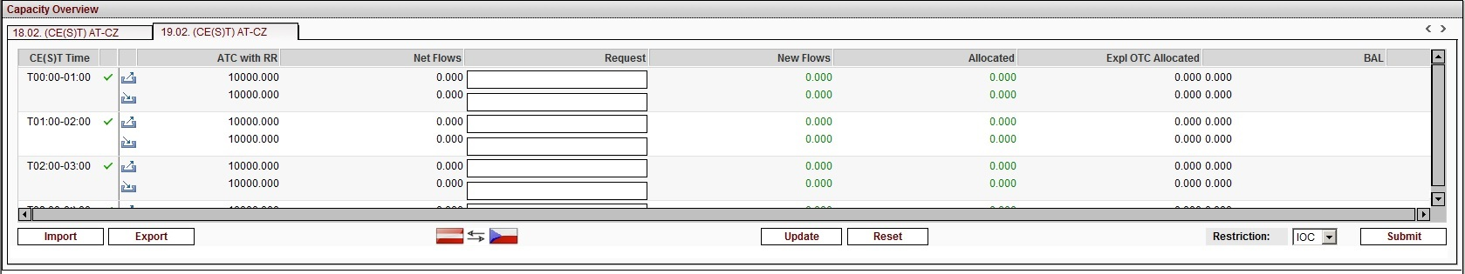
Daily Capacity Overview

Main
The menu item Main includes the items Change Password and Logout. Change Password
The change password functionality is already described in chapter 2.2.2.2 Change Password.

Logout

Description
The Logout functionality allows the user to logout from CMM.

Screen elements

Preferences
The menu item Preferences allows the Explicit Participant User to choose additional functionalities to be displayed on the Capacity Overview GUI. Only functionalities which are configured for the respective border or interconnector are depicted here. If an option is not selected the information is not displayed on the GUI.

Show Contract UTC / Contract Local / Contract CET Time

Description
The option Show Contract Local Time; Show Contract UTC, Show Contract CET Time displays additional columns within the Capacity Overview section (Daily Capacity Overview and Daily on behalf Capacity Overview). The columns contain the delivery interval names converted into the user’s local time, UTC-Time and CET-Time.

Functionality
When the item is selected in the Preferences drop down menu the respective additional column is shown in the Capacity Overview.

Screen elements
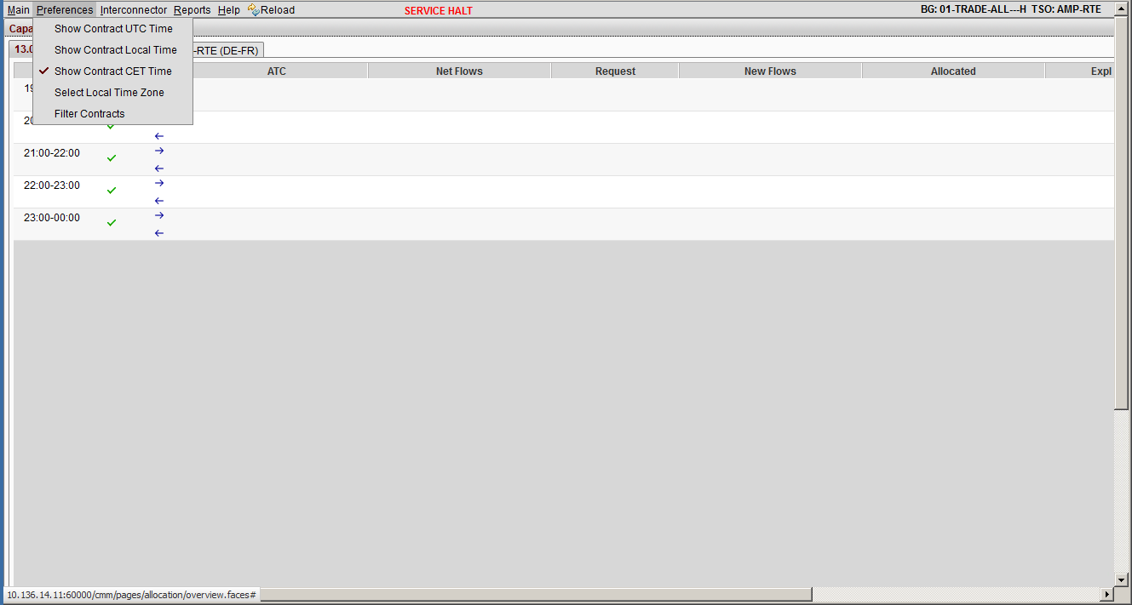
Capacity Overview & Preferences Drop down menu
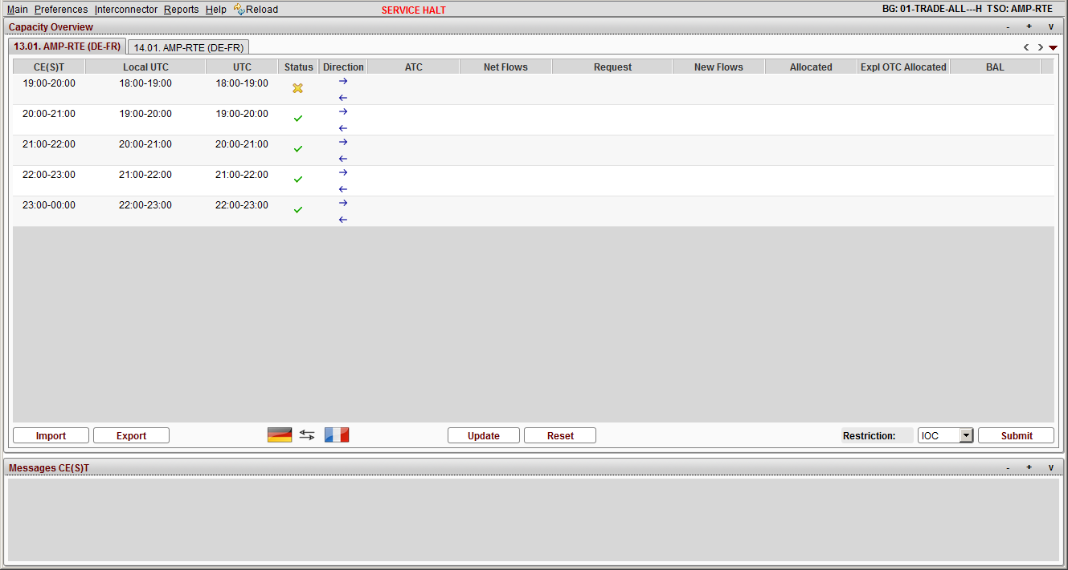
Capacity Overview with CET;UTC and Local Time columns

Select Local Time Zone

Description
Selecting the option Select Local Local Time Zone gives the user to possibility to determine its local time zone, in order to display an additional column within the Capacity Overview section, which contains the delivery interval names converted into the users’ local time.

Functionality
When the item is selected a pop-up appears with a drop down containing UTC-12 up to UTC+12, where the user can select its time zone.
Once the time zone is selected, the impact of the selection is shown in local time column.
By the time the user has reviewed its selection he can select OK, which will save and close the pop-up, or cancel, which will just close the pop-up window.

Screen elements
Local time zone selected and displayed
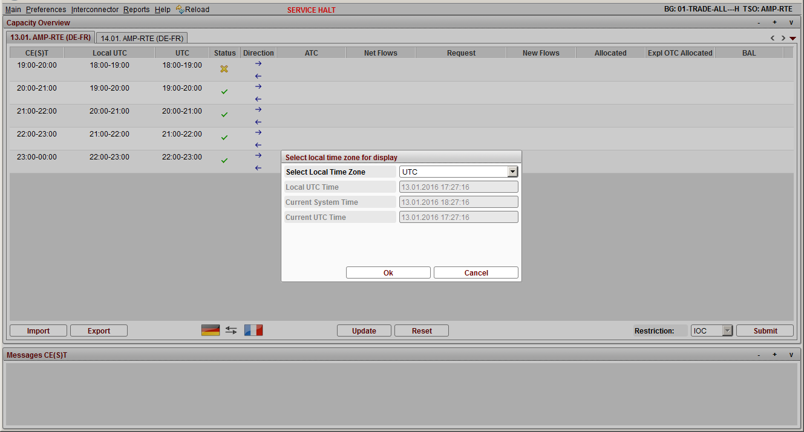
Select local time zone for display menu

Filter Contracts

Description
With the Filter Contracts functionality the user is able to limit the number of delivery intervals which are displayed in the Capacity Overview in order to ease the usage.

Functionality
Once the option has been selected a popup appears with two drop down boxes:
- Filter Contracts from, and
- Filter Contracts to
The user is unable to select a time in the ‘to’ drop down which is earlier than the time they have selected in the ‘from’ box. Once an interval has been indicated the user can then select Reset, Ok or Cancel. Cancel closes the pop-up and does nothing further, Ok closes the pop-up, applies the indicated filter to both the current day delivery intervals and the following day’s delivery intervals and Reset returns the “from” and “to” selections to null.

Screen elements
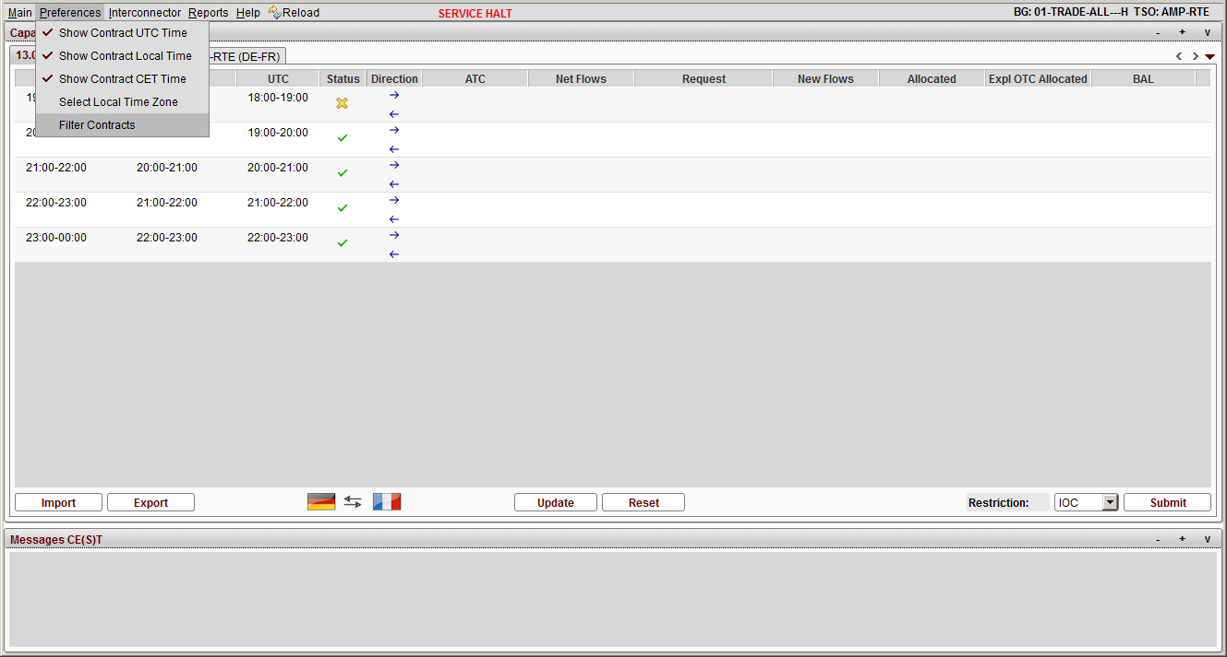
Preference Drop Down menu
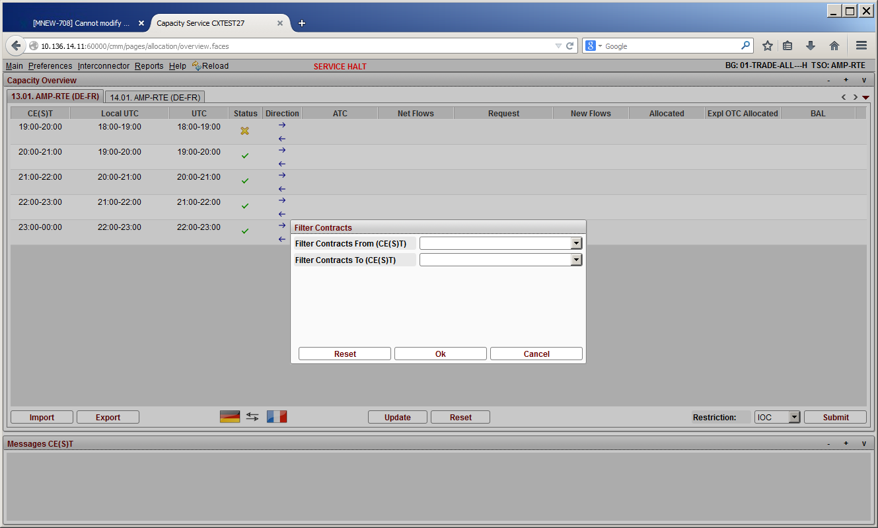
Filter Contracts Time Definition screen
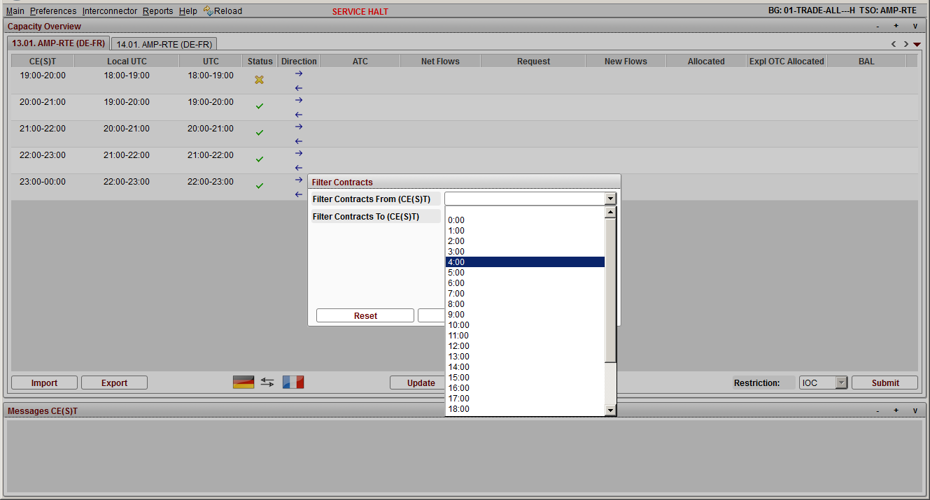
Time Drop Down menu - Filter Contracts from Field
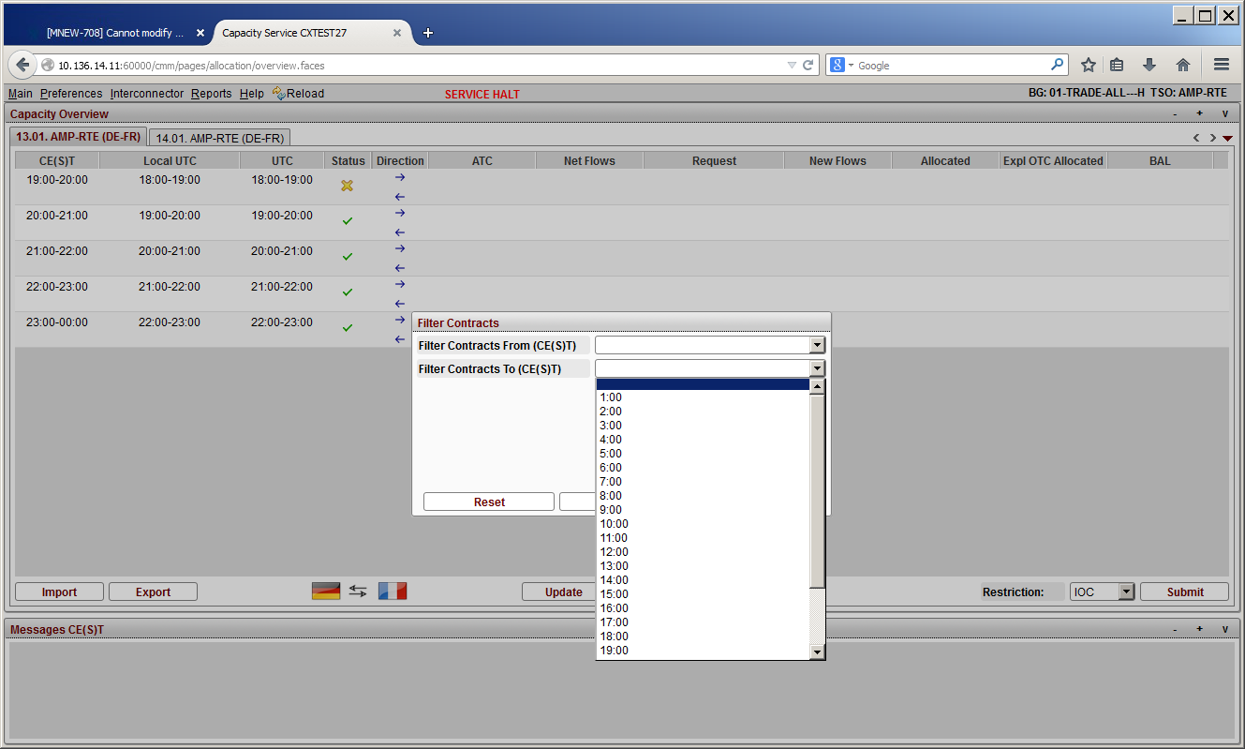
Time Drop Down menu - Filter Contracts to Field

Interconnector

Change Interconnector

Description
The menu item Interconnector allows the Explicit Participant User to switch to any assigned Interconnector for the capacity overview. The cursor on the Interconnector opens a drop down menu, which shows all assigned Interconnectors and the respective border in brackets.

Functionality
By clicking on the menu item, all Interconnectors for which the user is registered is visible. The selected interconnector determines the content of the other 2 panels Capacity Overview, and Messages.

Screen elements
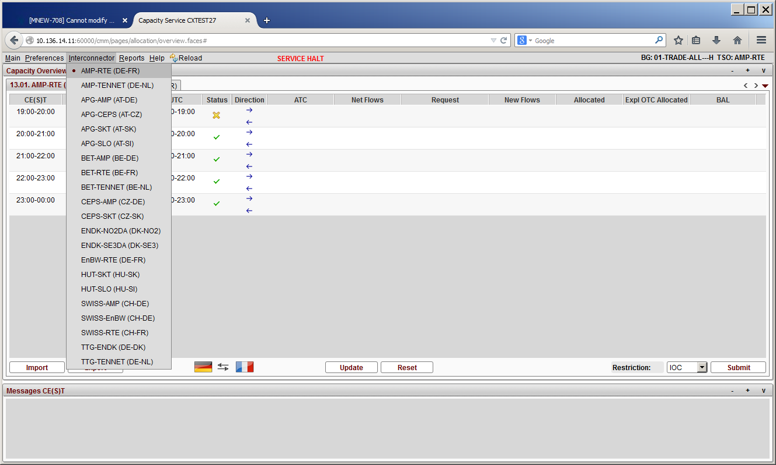
Selection of registered Borders – before change of the interconnector

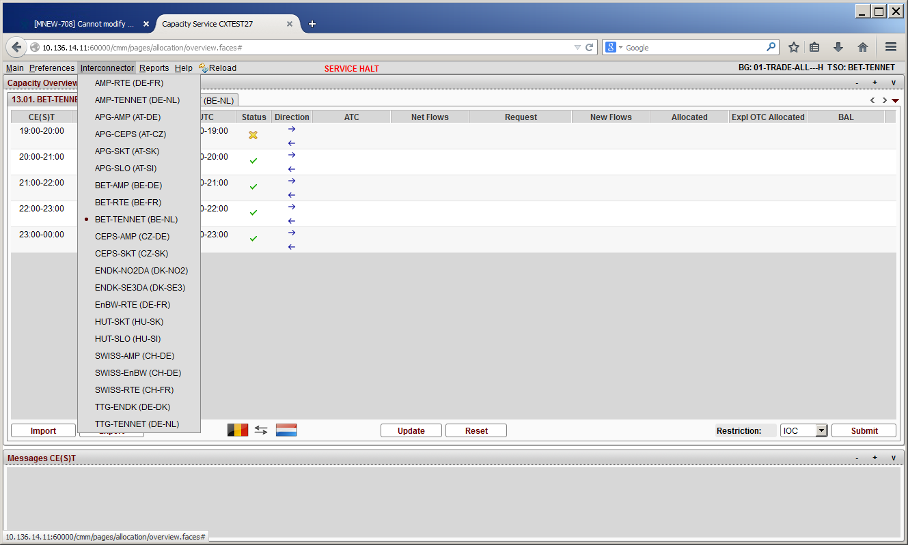
Selection of registered Borders – after change of the interconnector

Reports

Description
The menu bar item Reports allows users to download reports on demand. The reports are either border- or interconnector-specific - they are generated for the currently selected interconnector. For interconnectors with a ‘Common ATC’ flag the reports are created with the values for the whole border. Interconnectors without a ‘Common ATC’ flag have separate reports even if they belong to the same border.
The reports can be downloaded by clicking the Download button in the reports drop down menu.
Available Reports are:
- Messages Report:
The Messages Report downloaded from the Reports Download includes both TSO User and Explicit Participant messages from all Balancing Groups of the respective border or interconnector.

- Allocated Capacity Report:
The Allocated Capacity report is for Explicit Participants of the platform. The report depicts all anonymized allocations per interconnector.

Functionality
When a user selects the Download button from the Reports section in the toolbar a dialog box appears. The date can be D, D+1 and history. The maximum interval is limited by the border configuration. The column Name specifies the type of report. The start and end dates are the platform dates i.e. as per CE(S)T.
By clicking on the respective download button, the download to the predefined is started.

Screen elements
Download Reports
Start Date | Start date of the data populated in the report
End Date | End date of the data populated in the report
Close | Button to close the report population

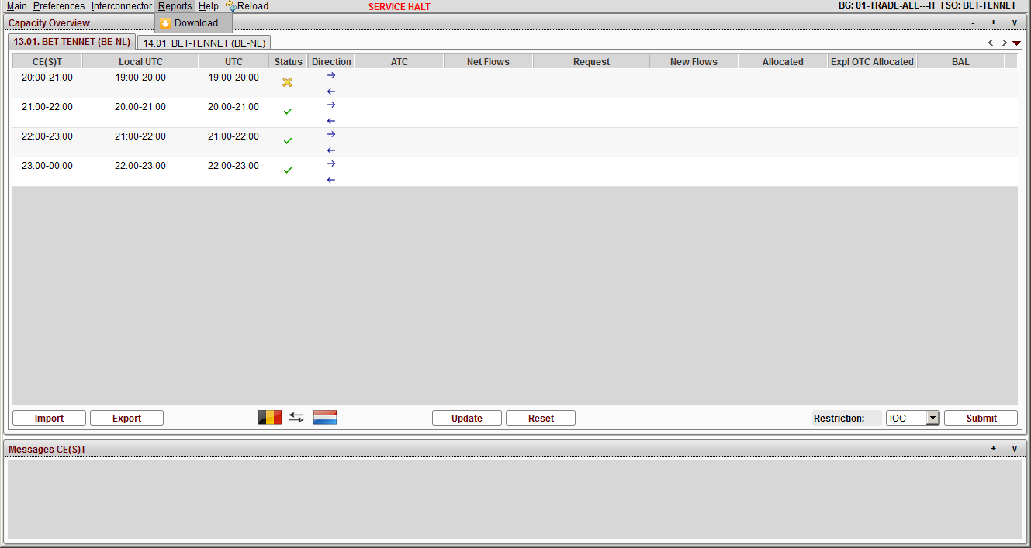
Download Button in Reports menu
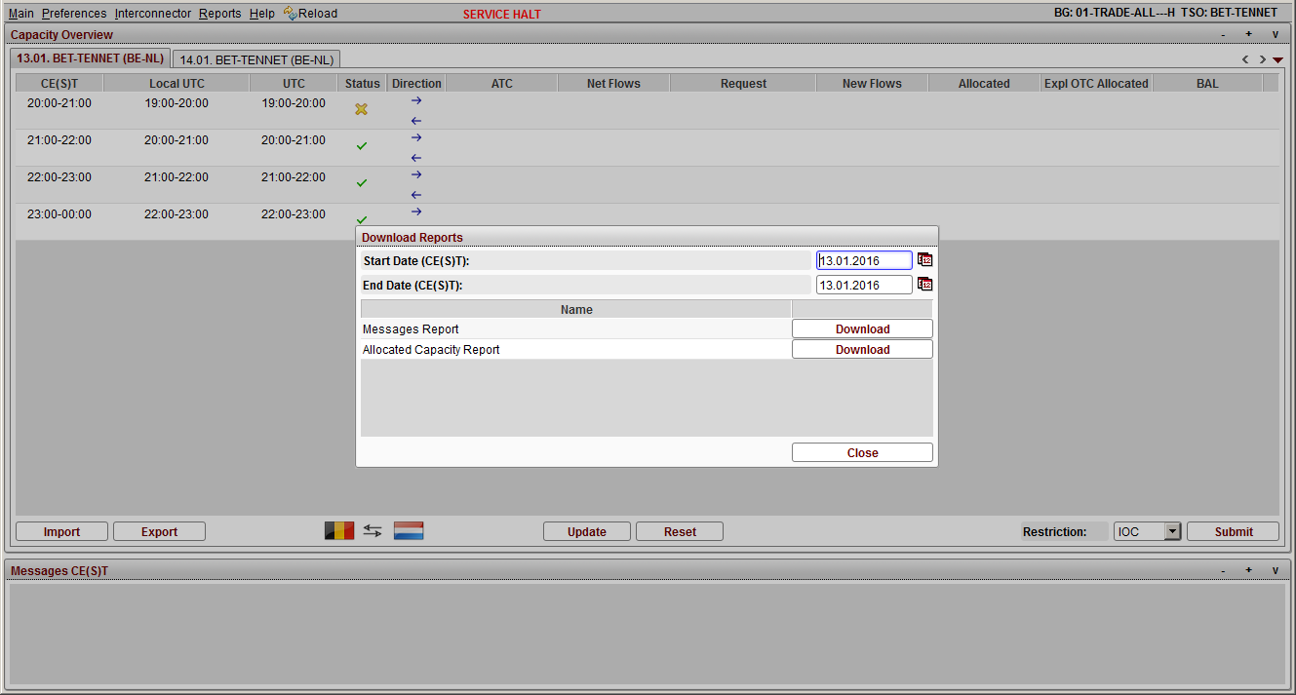
Dialog box for report download specification
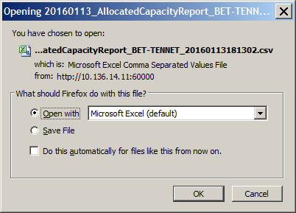
Specification of download path

Help

Description
The menu item Help provides the user with information about the current software version.

Functionality
When a user selects the About button in the Help Dropdown menu, a dialog box appears with the information of the current software version.

Screen elements
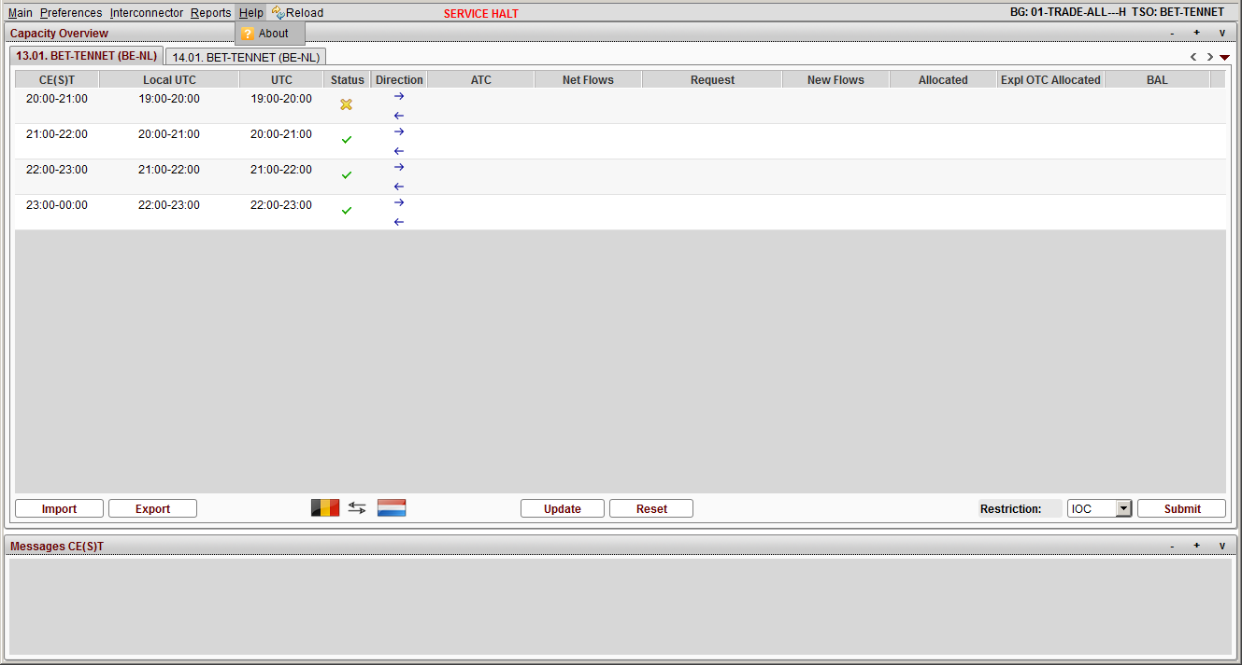
Capacity Overview - About button
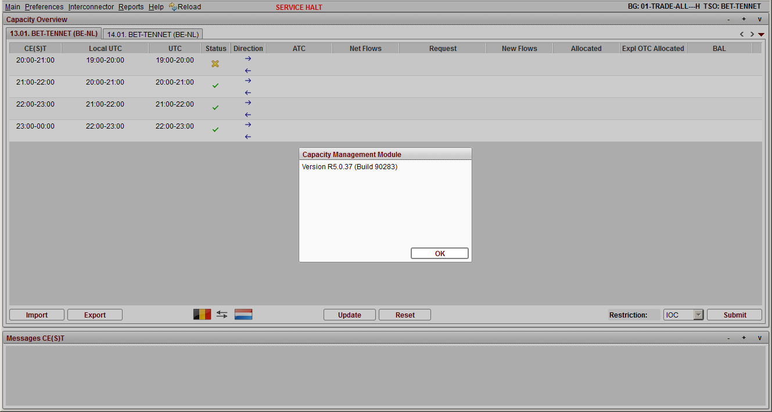
Dialog Box with Version Information

Reload

Description
The menu bar item Reload allows users to reload the CMM window.

Functionality
Clicking on Reload button on the menu bar updates the CMM window. This is the only way to update the window.

Screen elements
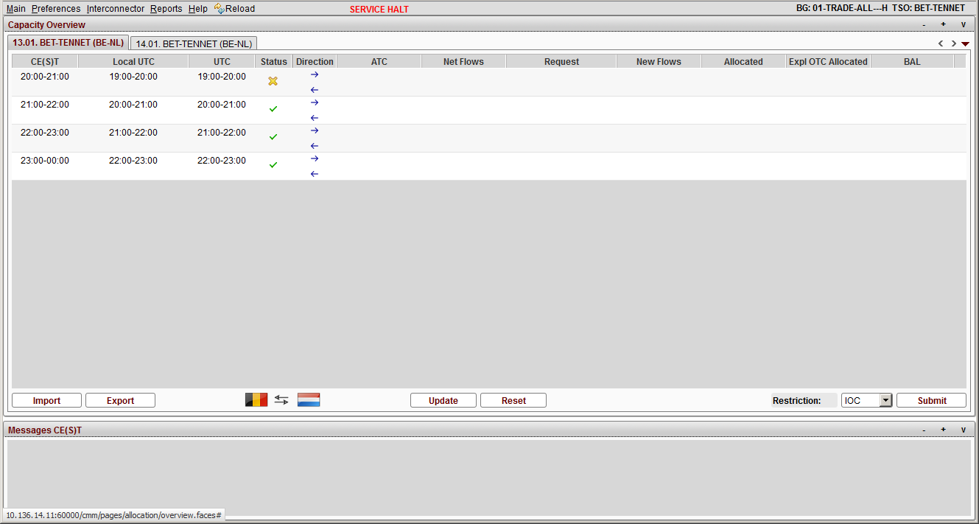
Capacity Overview – Reload button

Messages Section

Description
In the Messages panel the last 25 system generated messages are displayed. The following different messages are displayed:
- System messages
- Error or warning messages

Screen elements
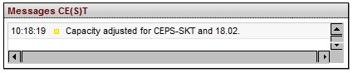
Messages panel

Explicit Participant Files
The following files are supported for the Explicit Participant and can be configured to use one (or several) of the three resolutions allowed by the system – hourly, 30-minute or 15-minute delivery intervals (PT60M, PT30M or PT15M):
File Name | Standard | File Type | Version | Release
BG Request |  | Auction Message | 1 | 0
BID | ECAN | Auction Message | 4 | 0
BG Allocation |  | Auction Result Message | 1 | 0
RED | ECAN | Auction Result Document | 4 | 0
RID | ECAN | Rights Document | 4 | 0

BG Request file
With the ‘Import’ button on the Explicit Participant GUI, a user can upload a Balancing Group Request file (in XML and CSV format) containing capacity requests for the balancing group.
Balancing Mechanism requests are also supported through file upload but the balancing mechanism entity code must be selected on the GUI before the file is uploaded (see chapter 4.1 Balancing Mechanism).
A popup appears asking the user to select a file. After the path to the file is displayed, the user can start or cancel the procedure by pressing OK or Cancel.
The file name of the imported file is not validated by the service.
The successful receipt of a BG file does not result in the sending of an ACK file.

BG Request XML-Schema
XML-Tags |  |  |  |  |  |  | m/o | Data Type | No. | Short Description/Comment
AuctionMessage |  |  |  |  |  |  | m | Structure | 1 | Defines the XML-schema version and release.  -DtdRelease=‘0’  -DtdVersion=‘1’
 | DocumentIdentification |  |  |  |  |  | o | 35 alphanumeric | 1 | Unique identification of the document for which the time series data is being supplied.  Not mandatory, any desired string.
 | DocumentType |  |  |  |  |  | m | 3 alphanumeric | 1 | The document type identifies the information of the document.  CMM allows the value:  X04=Intraday request
 | DocumentVersion |  |  |  |  |  | m | 3 numeric | 1 | Version of the document being sent. A document may be sent several times, each transmission being identified by a different version number that starts at 1 and increases sequentially.  Version number (integer): 1-999  Note: Has to be higher than already uploaded file during a calendar day.
 | DocumentProcessType |  |  |  |  |  | m | 3 alphanumeric | 1 | Indicates the nature of process that the schedule addresses.  CMM allows the value:  A01=Day ahead
 | DocumentClassificationType |  |  |  |  |  | m | 3 alphanumeric | 1 | A type that is used to classify the document by aggregation or classification.  CMM allows the value:  A01=Detailed Type
 | DateOfDocumentCreation |  |  |  |  |  | m | 20 alphanumeric | 1 | The date and time must be expressed in UTC as YYYY-MM-DDTHH:MM:SSZ.  e.g. 2013-10-05T13:00:00Z
 | SenderIdentification |  |  |  |  |  | m | 16 alphanumeric | 1 | Identification and coding scheme for the party who is sending the document (BG-User, which imports the file).  codingScheme=‘A01’  A01=EIC (for example)
 | SenderRole |  |  |  |  |  | m | 3 alphanumeric | 1 | Identification of the role that is played by the sender.  CMM allows the value:  A01=Balancing Group participant
 | ReceiverIdentification |  |  |  |  |  | m | 16 alphanumeric | 1 | Identification and coding scheme for the party who is receiving the document.  codingScheme=‘A01’  A01=EIC
 | ReceiverRole |  |  |  |  |  | m | 3 alphanumeric | 1 | Identification of the role that is played by the receiver.  CMM allows the values:  A07=Transmission capacity allocator
 | AuctionTimeInterval |  |  |  |  |  | m | 35 alphanumeric | 1 | The beginning and ending date and time of the period covered by the document.  The start and end date and time must be expressed as YYYY-MM-DDTHH:MMZ/YYYY-MM-DDTHH:MMZ. The time must always be expressed in UTC.  e.g. v=‘2013-11-11T23:00Z/2013-11-12T23:00Z’
 | AuctionTimeSeries |  |  |  |  |  | m | Structure | 2 | Object used for the transmission of specific time series. A time series may be considered as a sequence of observations of a single process taken at equal time intervals.
 |  |  | AuctionTimeSeriesIdentification |  |  |  | m | 35 alphanumeric | 1 | The identification of the time series instance.  This must be a unique number that is assigned by the auction office for each time series in the document  Is ignored by CMM.  All Information about TSO, BG, Border are extracted from InArea, OutArea, InParty, OutParty, etc.
 |  |  | AuctionTimeSeriesVersion |  |  |  | m | 3 numeric | 1 | Any desired string
 |  |  | BusinessType |  |  |  | m | 3 alphanumeric | 1 | The exact business nature identifying the principal characteristic of a schedule time series.  CMM allows the value:  Y09=Intraday request
 |  |  | Product |  |  |  | m | 13 numeric | 1 | The identification of the nature of an energy product such as power, energy, reactive power, etc.  8716867000016=Power
 |  |  | ObjectAggregation |  |  |  | m | 3 alphanumeric | 1 | CMM allows the value:  A01=Area
 |  |  | InArea |  |  |  | m | 18 alphanumeric | 1 | The coding scheme and identification for the area to which the energy is to be delivered.  codingScheme=‘A01’  A01=EIC (for example)
 |  |  | OutArea |  |  |  | m | 18 alphanumeric | 1 | The coding scheme and identification for the area from which the energy comes from.  codingScheme=‘A01’  A01=EIC (for example)
 |  |  | InParty |  |  |  | m | 16 alphanumeric | 1 | The identification and coding scheme for the party of concern.  codingScheme=‘A01’  A01=EIC (for example)
 |  |  | OutParty |  |  |  | m | 16 alphanumeric | 1 | The identification and coding scheme for the party of concern.  codingScheme=‘A01’  A01=EIC (for example)
 |  |  | MeasurementUnit |  |  |  | m | 3 alphanumeric | 1 | The unit of measure that is applied to the quantities in which the time series is expressed.  CMM allows the value:  MAW=Mega watt
 |  |  | Period |  |  |  | m | Structure | 1 | Object used to identify the period that the interval quantities cover and the resolution of each step within the period.
 |  |  |  | TimeInterval |  |  | m | 35 alphanumeric | 1 | The start and end date and time of the time interval of the period in question.  The start and end date and time must be expressed in compliance with the following format: YYYY-MM-DDTHH:MMZ/YYYY-MM-DDTHH:MMZ.  E.g. v=‘2013-11-11T23:00Z/2013-11-12T23:00Z’  The time must always be expressed in UTC.
 |  |  |  | Resolution |  |  | m | 35 alphanumeric | 1 | Defines the number of units of time that compose an individual step within a period.  CMM allows the values:  PT15M=Quarter-hourly delivery intervals (15 min.)  PT30M=Half-hourly delivery intervals (30 min.)  PT60M=Hourly delivery intervals (60 min.)
 |  |  |  | Interval |  |  | m | structure | variable | Object used for the transmission of each individual period and its associated quantity.  The expected value depends on the configured resolution - PT15M/PT30M/PT60M.  On the summer- and the winter-time changes there is 92/46/23 (PT15M/PT30M/PT60M) and 100/50/25 (PT15M/PT30M/PT60M) intervals.
 |  |  |  |  |  | Pos | m | 6 numeric | 1 | This information provides the relative position of a period within a tender interval.
 |  |  |  |  |  | Qty | m | 17 numeric | 1 | This information defines the quantity that is tendered for the interval in question and that is expressed in the Measurement Unit Quantity.  Quantity: > 999 MW is ignored!
BG Request XML-Schema

BID File
With the ‘Import’ button on the Explicit Participant GUI, a user can also upload a BID file based on the ENTSO-E ECAN standard. The file contains capacity requests for the balancing group.
Balancing Mechanism requests are also supported through file upload but the balancing mechanism entity code must be selected on the GUI before the file is uploaded.
A popup appears asking the user to select the file. After the path to the file is displayed, the user can start or cancel the procedure by pressing OK or Cancel.
The file name of the imported file is not validated by the service.
The successful receipt of a BID file does not result in the sending of an ACK file.

BID XML-Schema
XML-Tags |  |  |  |  |  |  | m/o | Data Type | No. | Short Description/Comment
BidDocument |  |  |  |  |  |  | m | Structure | 1 | Defines the XML-schema version and release.  -DtdRelease=‘0’  -DtdVersion=‘4’
 | DocumentIdentification |  |  |  |  |  | m | 35 alphanumeric | 1 | Unique identification of the document for which the time series data is being supplied.
 | DocumentType |  |  |  |  |  | m | 3 alphanumeric | 1 | The document type identifies the information of the document.  CMM allows the value:  A24=Bid Document
 | DocumentVersion |  |  |  |  |  | m | 3 numeric | 1 | Version of the document being sent. A document may be sent several times, each transmission being identified by a different version number that starts at 1 and increases sequentially.  Version number (integer): 1-999  Note: Has to be higher than already uploaded file during a calendar day.
 | SenderIdentification |  |  |  |  |  | m | 16 alphanumeric | 1 | Identification and coding scheme for the party who is sending the document (BG-User, which imports the file).  codingScheme=‘A01’  A01=EIC (for example)
 | SenderRole |  |  |  |  |  | m | 3 alphanumeric | 1 | Identification of the role that is played by the sender.  CMM allows the value:  A29=Capacity Trader
 | ReceiverIdentification |  |  |  |  |  | m | 16 alphanumeric | 1 | Identification and coding scheme for the party who is receiving the document.  codingScheme=‘A01’  A01=EIC (for example)
 | ReceiverRole |  |  |  |  |  | m | 3 alphanumeric | 1 | Identification of the role that is played by the receiver.  CMM allows the values:  A07=Transmission capacity allocator
 | CreationDateTime |  |  |  |  |  | m |  | 1 | Date and time of creation of the document expressed in UTC as YYYY-MM-DDTHH:MM:SSZ.
 | BidTimeInterval |  |  |  |  |  | m | 35 alphanumeric | 1 | The beginning and ending date and time of the period covered by the document.  The start and end date and time must be expressed as YYYY-MM-DDTHH:MMZ/YYYY-MM-DDTHH:MMZ. The time must always be expressed in UTC.  e.g. v=‘2013-11-11T23:00Z/2013-11-12T23:00Z’
 | Domain |  |  |  |  |  |  | 18 alphanumeric |  | The domain covered within the Reserve Bid Document.  codingScheme=‘A01’  A01=EIC (for example)
 | SubjectParty |  |  |  |  |  | m | 16 alphanumeric | 1 | The Party for whom the bid is being submitted.
 | SubjectRole |  |  |  |  |  | m | 3 alphanumeric | 1 | The role of the Subject Party.  CMM allows the value:  A29=Capacity Trader
 | BidTimeSeries |  |  |  |  |  | m | Structure | 2 | Object used for the transmission of specific time series. A time series may be considered as a sequence of observations of a single process taken at equal time intervals.
 |  |  | BidIdentification |  |  |  | m | 35 alphanumeric | 1 | The identification attributed by the sender that uniquely identifies the tender. This must be unique over time and guarantee the non-duplication of the tender for the sender in future tenders.
 |  |  | AuctionIdentification |  |  |  | m | 35 alphanumeric | 1 | The identification linking the tender to a set of specifications created by the Reserve Allocator.
 |  |  | BusinessType |  |  |  | m | 3 alphanumeric | 1 | The exact business nature identifying the principal characteristic of a schedule time series.  CMM allows the value:  A03=External Trade Explicit Capacity
 |  |  | InArea |  |  |  | m | 18 alphanumeric | 1 | The coding scheme and identification for the area to which the energy is to be delivered.  codingScheme=‘A01’  A01=EIC
 |  |  | OutArea |  |  |  | m | 18 alphanumeric | 1 | The coding scheme and identification for the area from which the energy comes from.  codingScheme=‘A01’  A01=EIC (for example)
 |  |  | MeasureUnitQuantity |  |  |  | m | 3 alphanumeric | 1 | The unit of measure that is applied to the quantities in which the time series is expressed.  CMM allows the value:  MAW=Mega watt
 |  |  | Currency |  |  |  | o | 3 alphanumeric | 1 | The currency in which the monetary amount is expressed.  This field is ignored by CMM.
 |  |  | MeasureUnitPrice |  |  |  | o | 3 alphanumeric | 1 | The unit of measure in which the price in the time series is expressed (MW, MWh, etc.).  This field is ignored by CMM
 |  |  | Divisible |  |  |  | m | 3 alphanumeric | 1 | An indication whether or not each element of the tender maybe partially accepted or not. The indication can be either “Yes” (A01) or “No” (A02).
 |  |  | BlockBid |  |  |  | m | 3 alphanumeric | 1 | An indication that the values in the period constitute a block tender and that they cannot be changed. The default value for this attribute is A02: “No”.
 |  |  | Period |  |  |  | m | Structure | 1 | Object used to identify the period that the interval quantities cover and the resolution of each step within the period.
 |  |  |  | TimeInterval |  |  | m | 35 alphanumeric | 1 | The start and end date and time of the time interval of the period in question.  The start and end date and time must be expressed in compliance with the following format: YYYY-MM-DDTHH:MMZ/YYYY-MM-DDTHH:MMZ.  E.g. v=‘2013-11-11T23:00Z/2013-11-12T23:00Z’  The time must always be expressed in UTC.
 |  |  |  | Resolution |  |  | m | 35 alphanumeric | 1 | Defines the number of units of time that compose an individual step within a period.  CMM allows the values:  PT15M=Quarter-hourly delivery intervals (15 min.)  PT30M=Half-hourly delivery intervals (30 min.)  PT60M=Hourly delivery intervals (60 min.)
 |  |  |  | Interval |  |  | m | structure | variable | Object used for the transmission of each individual period and its associated quantity.  The expected value depends on the configured resolution - PT15M/PT30M/PT60M.  On the summer- and the winter-time changes there is 92/46/23 (PT15M/PT30M/PT60M) and 100/50/25 (PT15M/PT30M/PT60M) intervals.
 |  |  |  |  |  | Pos | m | 6 numeric | 1 | This information provides the relative position of a period within a tender interval.
 |  |  |  |  |  | Qty | m | 17 numeric | 1 | This information defines the quantity that is tendered for the interval in question and that is expressed in the Measurement Unit Quantity.  Quantity: > 999 MW is ignored!
BID XML-Schema

BG Allocation file
The Balancing Group Allocation file can be exported online from the Explicit Participant GUI by the user in XML and CSV format. They are offered to the balancing group user and contain the capacity allocations for the own balancing group and the currently assigned TSO.
The files are created:
- Per Balancing Group
- Per assigned TSO
- Per calendar day

BG Allocation XML-Schema
Filename: <YYYYMMDD>_AIR_<BG_user[EIC Code]>_<auction coordinator[EIC Code]>_<Version number>_RESULT_<yyyy-mm-ddThh-mm-ssZ>.xml

- <YYYYMMDD> = Date of delivery
- <VVV> = Version Number of file is equal to the Document Version of the Capacity Request file.
- <yyyy-mm-ddThh-mm-ssZ> = Date and Time of document creation

XML-Tags |  |  |  |  |  | m/o | Data Type | No. | Short Description/Comment
AuctionResultMessage |  |  |  |  |  | m | Structure | 1 | Defines the XML-schema version and release.  -DtdRelease=‘0’  -DtdVersion=‘1’
 | DocumentIdentification |  |  |  |  | o | 35 alphanumeric | 1 | Unique identification of the document for which the time series data is being supplied.  Not mandatory, any desired string.
 | DocumentType |  |  |  |  | m | 3 alphanumeric | 1 | Document Type of the last imported Capacity Request file.  The value is filled with ‘XXX’.
 | DocumentVersion |  |  |  |  | m | 3 numeric | 1 | Document Version of the last imported Capacity Request file.  The value is filled with ‘XXX’.
 | DocumentProcessType |  |  |  |  | m | 3 alphanumeric | 1 | Indicates the nature of process that the schedule addresses.  CMM produces the value:  A01=Day ahead
 | DocumentClassificationType |  |  |  |  | m | 3 alphanumeric | 1 | A type that is used to classify the document by aggregation or classification.  CMM produces the value:  A01=Detailed Type
 | DateOfDocumentCreation |  |  |  |  | m | 20 alphanumeric | 1 | The date and time must be expressed in UTC as YYYY-MM-DDTHH:MM:SSZ.  e.g. 2013-10-05T13:00:00Z
 | DocumentStatus |  |  |  |  | m | 3 alphanumeric | 1 | The coded status of the document being sent.
 | SenderIdentification |  |  |  |  | m | 16 alphanumeric | 1 | Identification and coding scheme of the party who is sending the document.  CMM produces  codingScheme=‘A01’ (EIC)  and  v=”11XID-CAPACITY-9”
 | SenderRole |  |  |  |  | m | 3 alphanumeric | 1 | Identification of the role that is played by the sender.  CMM produces the value:  A07=Transmission capacity allocator
 | ReceiverIdentification |  |  |  |  | m | 16 alphanumeric | 1 | Identification and coding scheme of the party who is receiving the document.  codingScheme=‘A01’  A01=EIC (for example)  BG-user, which exports the file - always equal to the rights holder
 | ReceiverRole |  |  |  |  | m | 3 alphanumeric | 1 | Identification of the role that is played by the receiver.  CMM produces the values:  A01=Balancing Group participant
 | AuctionTimeInterval |  |  |  |  | m | 35 alphanumeric | 1 | The beginning and ending date and time of the period covered by the document.  The start and end date and time must be expressed as YYYY-MM-DDTHH:MMZ/YYYY-MM-DDTHH:MMZ. The time must always be expressed in UTC.  e.g. v=‘2013-11-11T23:00Z/2013-11-12T23:00Z’
 | AuctionTimeSeries |  |  |  |  | m | Structure | 2 | Object used for the transmission of specific time series. A time series may be considered as a sequence of observations of a single process taken at equal time intervals.
 |  | AuctionTimeSeriesIdentification |  |  |  | m | 35 alphanumeric | 1 | The identification of the time series instance.  This must be a unique number that is assigned by the auction office for each time series in the document  Is ignored by CMM.  All Information is extracted from InArea, OutArea, InParty, OutParty, etc.
 |  | AuctionTimeSeriesVersion |  |  |  | m | 3 numeric | 1 | The same as BG-Request document version
 |  | BusinessType |  |  |  | m | 3 alphanumeric | 1 | The exact business nature identifying the principal characteristic of a schedule time series.  CMM produces the value:  Y04=Capacity Min  Y05=Capacity Max
 |  | Product |  |  |  | m | 13 numeric | 1 | The identification of the nature of an energy product such as power, energy, reactive power, etc.  8716867000016=Power
 |  | ObjectAggregation |  |  |  | m | 3 alphanumeric | 1 | CMM produces the value:  A01=Area
 |  | InArea |  |  |  | m | 18 alphanumeric | 1 | The identification and coding scheme for the area where the energy is to be delivered.  codingScheme=‘A01’  A01=EIC
 |  | OutArea |  |  |  | m | 18 alphanumeric | 1 | The identification and coding scheme for the area from which the energy comes from.  codingScheme=‘A01’  A01=EIC
 |  | InParty |  |  |  | m | 16 alphanumeric | 1 | The identification and coding scheme of the party of concern.  codingScheme=‘A01’  A01=EIC
 |  | OutParty |  |  |  | m | 16 alphanumeric | 1 | The identification and coding scheme for the party of concern.  codingScheme=‘A01’  A01=EIC
 |  | MeasureUnit |  |  |  | m | 3 alphanumeric | 1 | The unit of measure that is applied to the quantities in which the time series is expressed.  CMM produces the value:  MAW=Mega watt
 |  | Period |  |  |  | m | Structure | 1 | Object used to identify the period that the interval quantities cover and the resolution of each step within the period.
 |  |  |  | TimeInterval |  | m | 35 alphanumeric | 1 | The start and end date and time of the time interval of the period in question.  The start and end date and time must be expressed in compliance with the following format: YYYY-MM-DDTHH:MMZ/YYYY-MM-DDTHH:MMZ.  E.g. v=‘2013-11-11T23:00Z/2013-11-12T23:00Z’  The time must always be expressed in UTC.
 |  |  |  | Resolution |  | m | 35 alphanumeric | 1 | Defines the number of units of time that compose an individual step within a period.  CMM produces the values:  PT15M=Quarter-hourly delivery intervals (15 min.)  PT30M=Half-hourly delivery intervals (30 min.)  PT60M=Hourly delivery intervals (60 min.)
 |  |  |  | Interval |  | m | structure | variable | Object used for the transmission of each individual period and its associated quantity.  The expected value depends on the configured resolution - PT15M/PT30M/PT60M.  On the summer- and the winter-time changes there is 92/46/23 (PT15M/PT30M/PT60M) and 100/50/25 (PT15M/PT30M/PT60M) intervals.
 |  |  |  |  | Pos | m | 6 numeric | 1 | This information provides the relative position of a period within a tender interval.
 |  |  |  |  | Qty | m | 17 numeric | 1 | This information defines the quantity that is tendered for the interval in question and that is expressed in the Measurement Unit Quantity.
BID Allocation XML-Schema

Result Document (RED)
The RED file is downloadable via the Export button in the Trading GUI. It contains the Balancing Group’s allocations executed after uploading a file or information why capacity request was not executed.

RED XML-Schema
XML-Tags |  |  |  |  | m/o | Data Type | No. | Short Description/Comment
AllocationResultDocument |  |  |  |  | m | Structure | 1 | Defines the XML-schema version and release.  -DtdRelease=‘0’  -DtdVersion=‘4’
 | DocumentIdentification |  |  |  | o | 35 alphanumeric | 1 | Unique identification of the document for which the time series data is being supplied.
 | DocumentVersion |  |  |  | m | 3 numeric | 1 | Version of the document being sent. A document may be sent several times, each transmission being identified by a different version number that starts at 1 and increases sequentially.
 | DocumentType |  |  |  | m | 3 alphanumeric | 1 | The document type identifies the information flow characteristics.  The initial code to be used is:  A25=Allocation result document
 | SenderIdentification |  |  |  | m | 16 alphanumeric | 1 | Identification and coding scheme of the party that is the owner of the document and is responsible for its content.  CMM produces  codingScheme=‘A01’ (EIC)  and  v=”11XID-CAPACITY-9”
 | SenderRole |  |  |  | m | 3 alphanumeric | 1 | Identification of the role that is played by the sender.  CMM produces the value:  ‘A07’ = Transmission capacity allocator
 | ReceiverIdentification |  |  |  | m | 16 alphanumeric | 1 | Identification and coding scheme of the party who is receiving the document.  codingScheme=‘A01’  A01=EIC
 | ReceiverRole |  |  |  | m | 3 alphanumeric | 1 | The receiver role, which identifies the role of the receiver within the document.  CMM produces the value:  A29=Capacity Trader
 | CreationDateTime |  |  |  | m | 20 alphanumeric | 1 | The date and time that the document was prepared for transmission by the application of the sender.  The time must be expressed in UTC as YYYY-MMDDTHH:MM:SSZ.
 | BidTimeInterval |  |  |  | m | 35 alphanumeric | 1 | The beginning and ending date and time of the period covered by the document. The bid period must be expressed with a UTC time as follows:  YYYY-MM-DDTHH:MMZ/YYYY-MM-DDTHH:MMZ.
 | Domain |  |  |  | m | 16 alphanumeric | 1 | The identification of the domain that is covered in the document. This impacts what auction identifications may be used.  codingScheme=‘A01’  A01=EIC (for example)
 | SubjectParty |  |  |  | m | 16 alphanumeric | 1 | The identifier and coding scheme for the party that is the subject of the documents time series. This could be a Balance Group or a Balance Responsible Party.  codingScheme=‘A01’  A01=EIC (for example)
 | SubjectRole |  |  |  | m | 3 alphanumeric | 1 | The Role of the Subject Party.  CMM produces the value:  A29=Capacity Trader
 | AllocationTimeSeries |  |  |  | m | Structure | 1
 |  | TimeSeriesIdentification |  |  | m | 35 alphanumeric | 1 | The identification of the time series instance.  This must be a unique number that is assigned by the auction office for each time series in the document  Is ignored by CMM. All information is extracted from InArea and OutArea.
 |  | BidDocumentIdentification |  |  | m | 35 alphanumeric | 1 | The identification of the document for which the bids or resales referenced are contained.
 |  | BidDocumentVersion |  |  | m | 3 numeric | 1 | Version of the bid or resales document having been sent.
 |  | BidIdentification |  |  | m | 35 alphanumeric | 1 | The identification of the time series that was used in the original bid or resale.  This is the unique number that is assigned by the bidder when he made his original bid or resale
 |  | AuctionIdentification |  |  | m | 35 alphanumeric | 1 | The identification linking the tender to a set of specifications created by the Reserve Allocator.
 |  | BusinessType |  |  | m | 3 alphanumeric | 1 | Identifies the nature of the time series.  CMM produces the value:  A03=External Trade Explicit Capacity
 |  | InArea |  |  | m | 18 alphanumeric | 1 | The coding scheme and identification for the area to which the energy is to be delivered.  codingScheme=‘A01’  A01=EIC
 |  | OutArea |  |  | m | 18 alphanumeric | 1 | The coding scheme and identification for the area from which the energy comes from.  codingScheme=‘A01’  A01=EIC
 |  | ContractType |  |  | m | 35 alphanumeric | 1 | The delivery interval type defines the conditions under which the capacity was allocated and handled.  The significance of this type is dependent on the in-area and out-area specific coded working methods.  The Transmission Capacity Allocator responsible for the area in question auctions defines the delivery interval type to be used.
 |  | ContractIdentification |  |  | m | 3 alphanumeric | 1 | The delivery interval identification of the time series instance.  This must be a unique number that is assigned by the auction office and shall be used for all references to the allocation.
 |  | MeasureUnitQuantity |  |  | m | 3 alphanumeric | 1 | The unit of measure that is applied to the quantities in which the time series is expressed.  CMM produces the value:  MAW=Mega watt
 |  | Period |  |  | m | Structure | 1 | Object used to identify the period that the interval quantities cover and the resolution of each step within the period.
 |  |  | TimeInterval |  | m | 35 alphanumeric | 1 | The start and end date and time of the time interval of the period in question.  The start and end date and time must be expressed in compliance with the following format: YYYY-MM-DDTHH:MMZ/YYYY-MM-DDTHH:MMZ.  E.g. v=‘2013-11-11T23:00Z/2013-11-12T23:00Z’  The time must always be expressed in UTC.
 |  |  | Resolution |  | m | 35 alphanumeric | 1 | Defines the number of units of time that compose an individual step within a period.  CMM produces the values:  PT15M=Quarter-hourly delivery intervals (15 min.)  PT30M=Half-hourly delivery intervals (30 min.)  PT60M=Hourly delivery intervals (60 min.)
 |  |  | Interval |  | m | structure | variable | Object used for the transmission of each individual period and its associated quantity.  The produced value depends on the configured resolution - PT15M/PT30M/PT60M.  On the summer- and the winter-time changes there is 92/46/23 (PT15M/PT30M/PT60M) and 100/50/25 (PT15M/PT30M/PT60M) intervals.
 |  |  |  | Pos | m | 6 numeric | 1 | This information provides the relative position of a period within a tender interval.
 |  |  |  | Qty | m | 17 numeric | 1 | This information defines the quantity that is tendered for the interval in question and that is expressed in the Measurement Unit Quantity.  Quantity: < 999 MW is ignored!
 |  | Reason |  |  | m | Structure | 1 | Object used for the transmission of status codes and comments.
 |  |  | ReasonCode |  | M | 3 alphanumeric | 1 | The reason code provides the status of the allocation. As many reason elements as necessary may be used.  CMM produces the values:  A01=Message fully accepted  A02=Message fully rejected
 |  |  | ReasonText |  | O | 512 alphanumeric | 1 | If the code does not provide all the information to clearly identify the justification of the allocation then the textual information may be provided.
RED XML-Schema

Right Document (RID)
The RID file contains the capacity allocations done through CMM for a given day for both directions for a respective border or interconnector for the respective balancing group which has access to it.
It contains un-netted, accumulated capacitiesThe file contains a maximum of two TimeSeries (both directions) with unique delivery interval identifications. If a balancing group has not made any intraday allocations the file is empty. If a balancing group has made allocations only in one direction, the TimeSeries for the other direction is filled with zero values.
Explicit Participants can download their allocated capacity as a RID file via the button ‘Export’ in the Explicit Participant GUI.

RID XML-Schema
XML-Tags |  |  |  |  |  | m/o | Data Type | No | Short Description/Comment
RightsDocument |  |  |  |  |  | m | Structure | 1 | Defines the XML-schema version and release.  -DtdRelease=‘0’  -DtdVersion=‘4’
 | DocumentIdentification |  |  |  |  | o | 35 alphanumeric | 1 | Unique identification of the document for which the time series data is being supplied.  Not mandatory for CMM, any desired string.
 | DocumentVersion |  |  |  |  | m | 3 numeric | 1 | Version of the document being sent. A document may be sent several times, each transmission being identified by a different version number.  Validated by the system, starts according to the settings with 1 or with 100.
 | DocumentType |  |  |  |  | m | 3 alphanumeric | 1 | The document type identifies the information flow characteristics.  CMM produces the value:  A23=Allocation
 | SenderIdentification |  |  |  |  | m | 16 alphanumeric | 1 | Identification and coding scheme of the party that is the owner of the document and is responsible for its content.  CMM produces  codingScheme=‘A01’ (EIC)  and  v=”11XID-CAPACITY-9”
 | SenderRole |  |  |  |  | m | 3 alphanumeric | 1 | The sender role, which identifies the role of the sender within the document.  CMM produces the value:  ‘A07’ = Transmission capacity allocator
 | ReceiverIdentification |  |  |  |  | m | 16 alphanumeric | 1 | Identification and coding scheme of the party who is receiving the document.  codingScheme=‘A01’  A01=EIC (for example)
 | ReceiverRole |  |  |  |  | m | 3 alphanumeric | 1 | The receiver role, which identifies the role of the receiver within the document.  CMM produces the values:  A29=Capacity Trader  A30=Interconnection Trade Responsible  A31=Nomination Validator
 | CreationDateTime |  |  |  |  | m | 20 alphanumeric | 1 | Date and time of the preparation of a message. The time must be expressed in UTC as: YYYY-MM-DDTHH:MM:SSZ.  e.g. 2013-10-05T13:00:00Z
 | ApplicableTimeInterval |  |  |  |  | m | 35 alphanumeric | 1 | The start date and time and the end date and time of an event. The time interval must be expressed in the following form: YYYY-MM-DDTHH:MMZ/YYYY-MM-DDTHH:MMZ.  The time must always be expressed in UTC.  e.g. v=‘2013-11-11T23:00Z/2013-11-12T23:00Z’
 | Domain |  |  |  |  | m | 16 alphanumeric | 1 | The identification and coding scheme of the domain that is covered in the Rights Document.  codingScheme=‘A01’  A01=EIC (for example)
 | DocumentStatus |  |  |  |  | m | 16 alphanumeric | 1 | The status of a rights document may be intermediate until gate closure then it becomes final.  CMM produces the values:  A01=Intermediate  A02=Final
 | RightsTimeSeries |  |  |  |  | m | Structure | 1-n | Object used for the transmission of specific time series.
 |  | TimeSeriesIdentification |  |  |  | m | 35 alphanumeric | 1 | The identification of the time series instance.  This must be a unique number that is assigned by the sender for each time series in the document.
 |  | BusinessType |  |  |  | m | 3 alphanumeric | 1 | Identifies the nature of the time series.  CMM produces the value:  A33=Authorised AAC
 |  | InArea |  |  |  | m | 18 alphanumeric | 1 | The identification and coding scheme of the area where the energy is going.  codingScheme=‘A01’  A01=EIC (for example)
 |  | OutArea |  |  |  | m | 18 alphanumeric | 1 | The identification and coding scheme for the area where the energy is coming from.  codingScheme=‘A01’  A01=EIC (for example)
 |  | RightsHolder |  |  |  | m | 16 alphanumeric | 1 | The Rights Holder is identified by a unique coded identification. Identification of the party who is owner of, or has the right to use, the transmission rights in question.
 |  | ContractIdentification |  |  |  | m | 35 alphanumeric | 1 | The delivery interval identification of the time series instance. This must be the number that has been assigned by the Transmission Capacity Allocator.
 |  | ContractType |  |  |  | m | 3 alphanumeric | 1 | The delivery interval type defines the conditions under which the rights were allocated and handled.  CMM produces the value:  A07=Intraday delivery interval
 |  | MeasureUnitQuantity |  |  |  | m | 3 alphanumeric | 1 | The unit of measure that is applied to the quantities in which the time series is expressed.  CMM produces the value:  MAW=Mega Watt
 |  | AuctionIdentification |  |  |  | m | 35 alphanumeric | 1 | The unique identification linking the capacity rights to a set of specifications created by the Transmission Capacity Allocator.
 |  | Period |  |  |  | m | Structure | 1 | Object used to identify the period that the interval quantities cover and the resolution of each step within the period.
 |  |  |  | TimeInterval |  | m | 35 alphanumeric | 1 | The start and end date and time of the time interval of the period in question. The time of the start and end of the period is expressed in UTC with the following format:  YYYY-MM-DDTHH:MMZ/YYYY-MM-DDTHH:MMZ.  E.g. v=‘2013-11-11T23:00Z/2013-11-12T23:00Z’
 |  |  |  | Resolution |  | m | 35 alphanumeric | 1 | Defines the number of units of time that compose an individual step within a period.  CMM produces the value:  PT15M=Quarter-hourly delivery intervals (15 min.)  PT30M=Half-hourly delivery intervals (30 min.)  PT60M=Hourly delivery intervals (60 min.)
 |  |  |  | Interval |  | m | structure | variable | Object used for the transmission of each individual period and its associated quantity.  The expected value depends on the configured resolution - PT15M/PT30M/PT60M.  On the summer- and the winter-time changes there is 92/46/23 (PT15M/PT30M/PT60M) and 100/50/25 (PT15M/PT30M/PT60M) intervals.
 |  |  |  |  | Pos | m | 6 numeric | 1 | This information provides the relative position of a period within an interval.
 |  |  |  |  | Qty | m | 17 numeric | 1 | This information defines the quantity that has been assigned to the nomination party for the interval in question and that is expressed in the Measurement Unit.
RID XML Schema

